Smartphone Apps for Diabetes Management
By David Kerr, MD; Charis Hoppe; and Ceara AxelrodMarch 2017

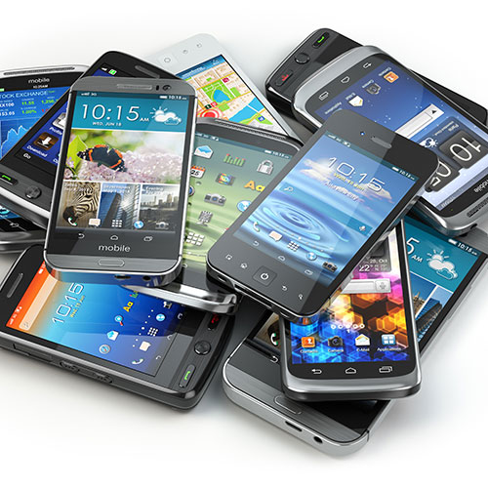
There’s an app for pretty much everything these days—reading magazines (Diabetes Forecast has its own!), playing games, even flipping a coin. A whole host of them focus on helping you get healthier, and that includes managing diabetes. But with thousands of diabetes apps available for download, how can you know which is best for you?
We’ve rounded up our favorite apps based on how well they help simplify daily diabetes management and how many self-care behaviors (below) they help encourage
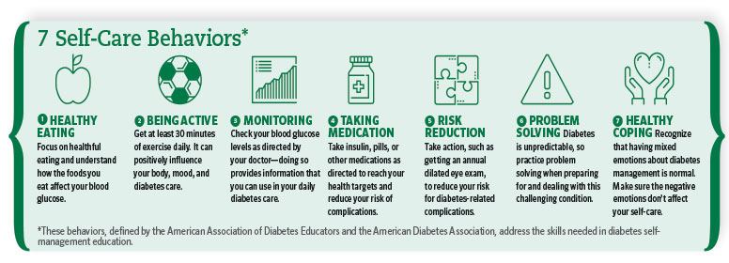

Glucose Buddy
This app lets you log your blood glucose level, carb intake, medication doses, A1C results, exercise, and more. It’s for people with type 1 and type 2 diabetes.
Pros: The app offers reminders to check your blood glucose and take your meds. If you use an Apple iPhone, you can register at glucosebuddy.com to sync your log to the website, input your glucose values, or print blood glucose and medication logs for a health care provider. Send reports to a health care provider via the app or website.
Cons: Glucose Buddy does not sync with meters, continuous glucose monitors (CGMs), or pumps. Both Android and Apple users can access glucosebuddy.com, but only Apple users can sync their app with the website; Android users have to manually input their log on the web portal. There is no way to back up your data, so if you lose your phone and you haven’t manually entered logbook data on the website (or if your Apple device didn’t sync), you’ll have to start over. A built-in calorie tracker and food database is planned, but no release date has been set yet.
Cost: Free

MySugr Diabetes Logbook
Created by people with diabetes, the MySugr app uses personalized feedback and challenges to encourage you to stay on top of your health. Log blood glucose, monitor your carbs, track insulin use, and get motivating feedback to help you cope with your diabetes. It’s intended for those with type 1 and type 2 diabetes. Good for more tech-savvy users.
Pros: Integrates with CGMs via Apple’s Health app and with Medtronic’s CareLink data management system. The picture-based user guide teaches you how to use the app in minutes. Its point system and challenges are motivating and rewarding. The app also generates reports for your health care provider.
Cons: MySugr doesn’t sync with blood glucose meters, but Apple users can use the MySugr Scanner app to scan and import readings, though the app can be glitchy. Does not sync with insulin pumps. To generate health reports as PDFs, you must buy MySugr PRO. The MySugr Coaching feature—a nice touch—is available only on Apple devices, and it can take a couple of hours to a few days to be able to text with a health coach through the app.
Cost: Free. MySugr PRO is $2.99 per month, or $27.99 per year. Or, for $19.99 per month, or $199.99 per year, get MySugr PRO with in-app counseling by certified diabetes educators (Apple devices only; Android compatibility to come).

DiabetesConnect
Record and track your blood glucose, meals, insulin injections, medications, and more. This app was created by people with diabetes for people with diabetes—both type 1 and type 2.
Pros: Use the app, or log on to the app’s online portal, to download data and reports to take to your next health care appointment. Clear graphics of your history and blood glucose statistics offer an overview of your current diabetes therapy.
Cons: This app doesn’t sync with meters, CGMs, or insulin pumps. Reminders for taking medication, insulin, or blood glucose measurements are available only to premium users who make an in-app purchase to cover a month, year, or lifetime membership.
Cost: Free. Premium membership is $1.99 a month, $16.99 a year (though this is available only on Apple
devices and will be discontinued in the future), or a one-time fee of $26.99 (on Apple devices) or $29.99 (Android devices).

Sugar Sense
This app tracks and logs your blood glucose level, carb intake, and weight. It’s intended for people with type 1 and type 2 diabetes.
Pros: Sugar Sense provides a community support forum for people with type 2 diabetes and offers diabetes prevention information. The app works with iHealth’s Smart Gluco-Monitoring System and its iHealth app, but only on Apple devices. It pulls data from the My Diet Diary app and from fitness trackers such as FitBit, Jawbone, and iHealth, and it sends data to Apple’s Health app.
Cons: The app doesn’t sync with CGMs or pumps. There is no community support forum for people with type 1 diabetes.
Cost: Free

One Drop
One Drop provides for food and exercise logging, plus peer and expert support, all in one place. This app is for people with type 1 diabetes and insulin-dependent type 2. Good for more tech-savvy users.
Pros: The app wirelessly syncs with the One Drop Chrome meter, as well as with insulin pumps and CGMs. Works with other Bluetooth meters, via Apple’s Health app. The app offers a diabetes-related news section and community support forum.
Cons: One Drop Premium requires you to buy the One Drop Chrome blood glucose monitoring system (which includes a meter, lancing device, 10 lancets, 100 test strips, and a carrying case) for an additional $99.95. Although you can still use the One Drop logging app for free, it won’t come with the extra features that One Drop Premium offers.
Cost: Free. One Drop Premium is $39.95 per month. It includes the One Drop diabetes management app, One Drop Chrome blood glucose monitoring system, unlimited test strips delivered to you, and 24-7
in-app text support from certified diabetes educators. There’s a one-time $99.95 fee for the One Drop Chrome system.

Diabetes and Blood Glucose Tracker (Apple); Diabetes and Diet Tracker (Android

This diabetes-management and weight-loss app (it works similarly on Apple and Android devices, despite the separate names) features a log for blood glucose readings, A1C results, food, exercise, blood pressure levels, and medication use plus reminders to check your blood glucose. Upgrade to the “maximum” version for integration with fitness trackers (such as Jawbone and Fitbit) and extra features—nutrition planning and more charts and reports. This is for people with type 1 or type 2 diabetes and for those seeking to lose weight.
Pros: Connects with blood glucose meters that work with Apple’s Health app. Log your food and exercise, and the app will provide you with personalized advice and support to keep you on track. Comprehensive food database. An online forum lets users ask questions of nurses and diabetes educators. An included guide teaches you how to use the app.
Cons: Does not sync with CGMs or insulin pumps.
Cost: One-time fee of $9.99. $60 per year (or $9 per month) for the “maximum” version, available for purchase within the app.
BG Monitor Diabetes
This blood glucose logging app provides insulin bolus calculation and blood glucose targets. It’s for people with type 1 and type 2 diabetes.
Pros: It’s easy to log your data entries and to see your blood glucose levels and trends. The developers have continued to improve the app based on user reviews.
Cons: It’s made for Android devices only and does not sync with meters, CGMs, or insulin pumps.
Cost: Free. Upgrade to Pro for a one-time fee of $4.99.
The authors: David Kerr, MD, is the director of research and innovation at the William Sansum Diabetes Center in Santa Barbara, California, and the creator of ’Appy Feet, an app for people with painful diabetic neuropathy, as well as DiabetesTravel.org and ExCarbs.com—two free resources for people with diabetes. Charis Hoppe is a project coordinator at the William Sansum Diabetes Center for the Santa Barbara 1,000 project. Ceara Axelrod is a data analyst and clinical researcher at the William Sansum Diabetes Center

